SUPERSTORE SALES DASHBOARD PROJECT

OBJECTIVE

To contribute to the success of a business by utilizing data analysis techniques, specifically focusing on time series analysis, to provide valuable insights and accurate sales forecasting.

DATA EXPORTING

Client has provided the data in excel worksheet format so we have imported excel worksheet into power bi.

DATA CLEANING

Data which client has provided was uncleaned so we have performed some data cleaning steps on raw data.

Values replaced

We have replaced ‘#n/a’ values by ‘0’ in Return column.

Columns removed

At the end we have 2 empty columns named as ‘ind1’ & ‘ind2’ we have removed those columns as those are empty.

Apart from this data is quite clean so let’s move on to dashboard creation.

DASHBOARD CREATION

KPI

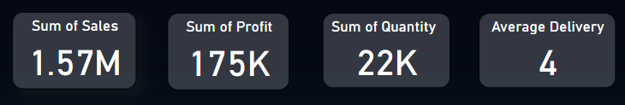

KPI’s plays the important role to get the overall idea of business.

From above KPI’s we get the idea of overall business of superstore.

From first kpi i.e. sum of sales we get to know the overll sales.

From second kpi we get the information about overall profit which is 175k.

From 3rd kpi we get the information about the sum of products quantity superstore has sold in 2 year.

And last kpi named as average delivery we get the information of average delivery days. To calculate this kpi use use datediff function and get the difference between order date and delivery date.

Donut chart 1

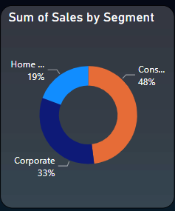

In above chart we have compared segment column with sales column which has 3 values.

As we can see in donut chart consumer segment has given more sale as compare to other segment i.e. 48%

Donut chart 2

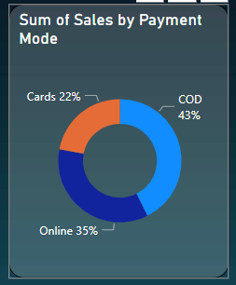

In above donut chart we have compared ‘payment mode’ column. In that customer had made payments using 3 payment modes cards, online & COD.

we can see 43% peoples are still preferring cash on delivery. May be this 43% peoples still have some trust issues regarding delivery.

Line chart 1

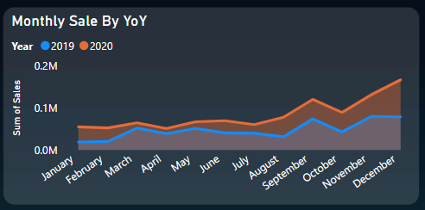

In above line chart we have compared year on year sale of year 2019 & 2020.

By seeing above chart, we definitely say that sales of store is increasing year by year.

On start of the year in we can see there is no any impressive movement in line chart but as we are moving forward to end of the year, we can see little upward trend in line chart for both the year its may be due to the festive season.

To increase the sale at the start of the year, store can come up with good offers.

Line chart 2

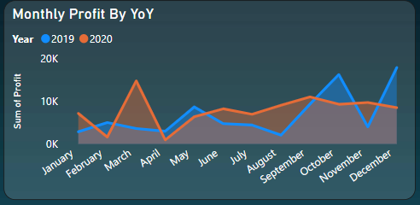

Just like sales we have compared year on year profit of superstore in above line chart.

In 2019 we can see there are some major upward downward trends in profit. There is no stability in profit in 2019.

Even if the sale is higher in November profit is surprisingly decreasing.

In 2020 there are no major movements. At the start of the year w can see major spike in profit which is suddenly come down in April and may but after that line is following up word trend.

Stack Bar Chart 1

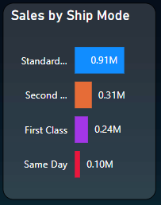

In above stack bar chart we have compare sales with ship mode. There are 4 types of ship mode store is providing. Even after providing same day, first class, second class delivery options higher amount of customers are preferring standard delivery option.

If store is charging any extra fees for this kind of delivery options then store need to think about to decrease that fees.

Stack Bar Chart 2

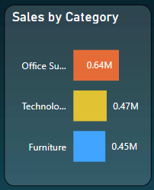

In above stack bar chart we have compare products category with ship mode.

There are 3 product categories are available in superstore. we don’t see any significant difference between all this 3 categories. Only the sales of office supplies is slightly higher than other two categories.

Stack Bar Chart 3

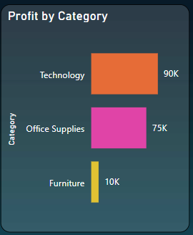

Just like sales we have compare profit with products categories. As we can see there is no significant difference between profit of technology product and profit of office supplies.

But store is making significantly lesser profit in furniture.

Map chart

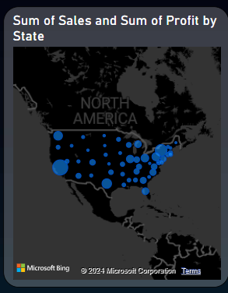

In above chart we have compared profit by reasons of USA.

As we can see superstore is making higher profit in east region as compare to other 4 regions.

Slicers



We have divided this visualization in four parts as per the regions of USA for better understanding.

By clicking on each region’s slicer we can see the visualization of that particular region.

Forecasting using line chart

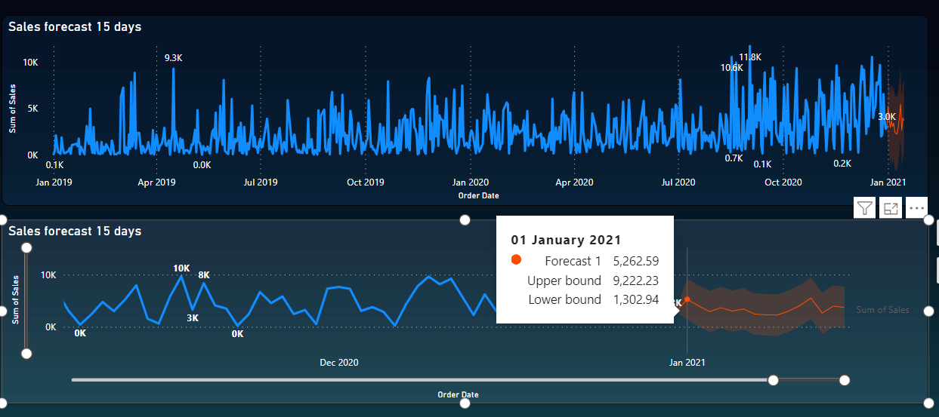

In above visualization we have forecasted the next 15 days sales of superstore using past 2 years of sales data. We have forecasted the sales from 1 January 2021 to 15 January 2021. For that we have used line chart.

Conclusion –

The analysis of the Superstore's sales data reveals several key insights:

Overall sales and profit have shown an upward trend over the two-year period, indicating positive growth for the business.

Consumer segment contributes significantly to sales, suggesting a focus on targeting this demographic for further growth opportunities.

Cash on delivery remains a popular payment mode, indicating potential trust issues or preferences among customers.

Sales and profit exhibit seasonality, with peaks during festive seasons, suggesting the effectiveness of promotions during these periods.

Standard delivery is the preferred option despite other faster delivery choices, prompting a review of delivery fees for faster options.

There is no significant variation in sales and profit across different product categories, except for furniture, which yields lower profits.

The East region generates the highest profits for the Superstore, indicating potential areas for expansion or investment.

Forecasting suggests continued sales growth in the upcoming 15 days, providing insights for inventory management and resource allocation.

Overall, these insights can guide strategic decisions to capitalize on strengths, address weaknesses, and drive further growth for the Superstore.